**Assignment on MongoDb Queries**

Name : Devika U H

USN : 01fe20mca031

**Create a collection of books which contains information such as book title, author, publication, edition, year of publication, ISBN number & type of the book.**

db.books.insertOne ({"book_title": "Big Data & Analytics", "author": "Seema Acharya", "publication": "Wiley publications","edition":2,"year_of_publication":2020,"ISBN number":12345,"type":"textbook"});

db.books.insertOne ({"book_title": "Intelligent Data Analytics", "author": "David J","publication":"Springer","edition":3,"year_of_publication":2015,"ISBN number":345,"type":"reference"});

db.books.insertOne ({"book_title": "Java J2EE","author":"Jim Keogh", "publication": "Tata McGraw Hill","edition":5,"year_of_publication":2007,"ISBN number":34524,"type":"textbook"});

db.books.insertOne ({"book_title": "Java Head First", "author": "Kathy Sierra","publication":"Oreilly","edition":2,"year_of_publication":2009,"ISBN number":3524,"type":"reference"});

db.books.insertOne ({"book_title":" Core Java", "author": "Cay S Horstmann","publication": "Gray Cornell","edition":4,"year_of_publication":2018,"ISBN number":93524,"type":"textbook"});

db.books.insertOne ({"book_title": "The Complete Reference-Java", "author": "Bert Bates","publication":"Oreilly","edition":4,"year_of_publication":2020,"ISBN number":98524,"type":"reference"});

db.books.insertOne ({"book_title": "Machine Learning", "author": "Tom Mitchell","publication":"McGraw-Hill","edition":3,"year_of_publication":2019,"ISBN number":98724,"type":"textbook"});

db.books.insertOne ({"book_title": "deep Learning", "author": "Tom Mitchell", "publication": "MIT Press Ebook","edition":4,"year_of_publication":2017,"ISBN number":98764,"type":"textbook"});

db.books.insertOne ({"book_title": "Hands on ML", "author": "Tom Mitchell", "publication": "McGraw-Hill Science","edition":3,"year_of_publication":2019,"ISBN number":98765,"type":"reference"});

db.books.insertOne ({"book_title" : "Hands on Java", "author": "Cay S Horstmann", "publication": "McGraw-Hill Science","edition":4,"year_of_publication":2020,"ISBN number":28765,"type":"textbook"});

**Query to retrieve the books which contains title as JAVA (case insensitive)**

db.books.find({“book_title”: {$regex: /java/i}})

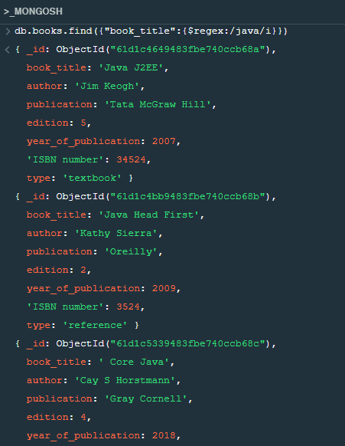

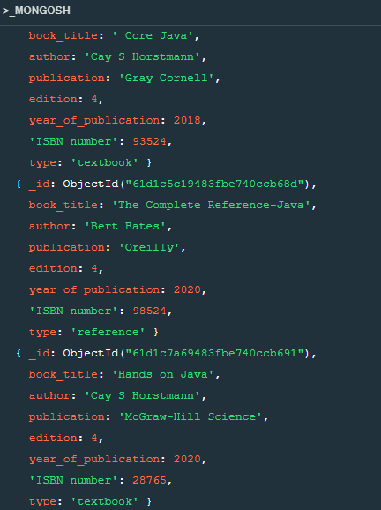

**Query to retrieve books which contains title as JAVA & year of publication** **greater than 2015**

db.books.find({“book_title”: {$regex: /java/i}, “year_of_publication”: {$gt: 2015}})

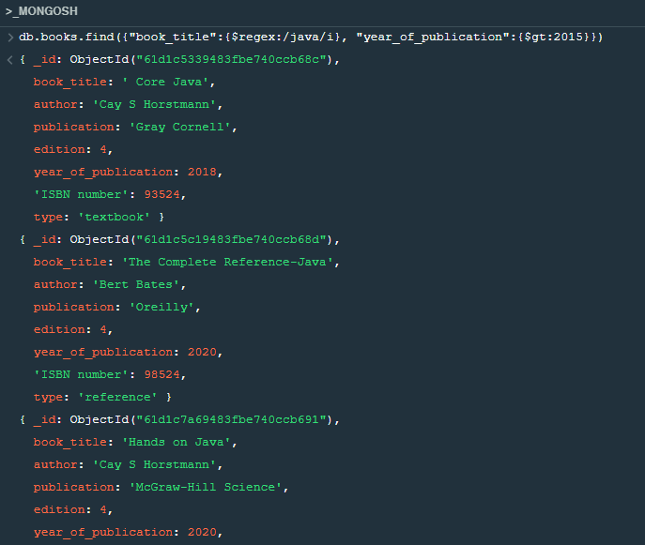

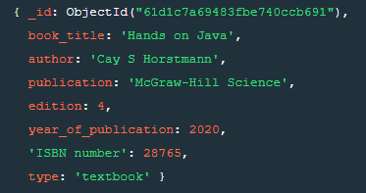

**Query to retrieve the books whose edition is between 3 to 4**

db.books.find ({“edition”: {$gte:3, $lte:4}})

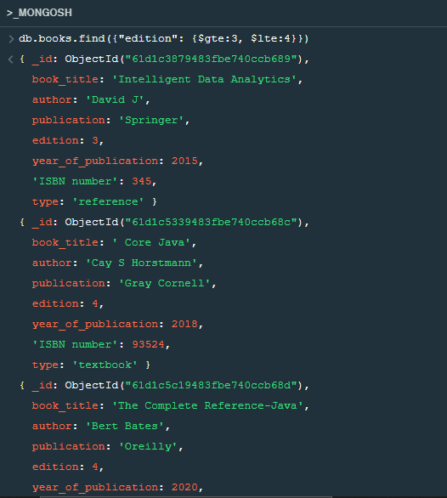

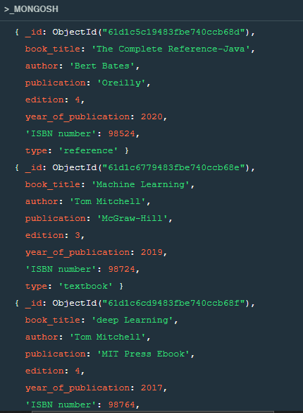

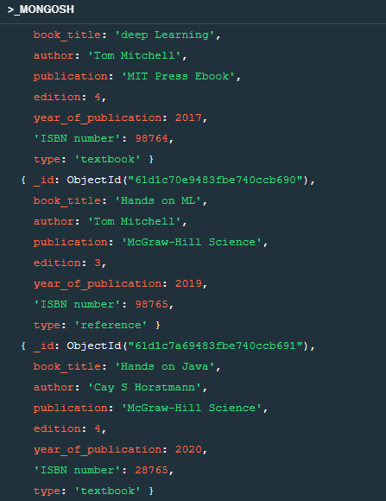

**Query to retrieve the name of the author who has published more than 2 books.**

db.books.find({“author” : {$gt : 1 }}).count();

2